Lab 15: Advanced Querying

Part 1. Setup

Step 1. Create a schema and the tables
DROP SCHEMA IF EXISTS lab15 CASCADE;
CREATE SCHEMA lab15;
SET search_path TO lab15;
CREATE TABLE employees (
employee_id SERIAL PRIMARY KEY,
first_name VARCHAR(50),
last_name VARCHAR(50),
department VARCHAR(50),
salary INTEGER,
manager_id INTEGER REFERENCES employees(employee_id),
tenure INTEGER
);
CREATE TABLE orders (
order_id SERIAL PRIMARY KEY,
region_id INTEGER,
product_name VARCHAR(50),
amount INTEGER,
status VARCHAR(20)
);
CREATE TABLE sales (
product_name VARCHAR(50),
year INTEGER,
sales_amount INTEGER
);
CREATE TABLE warehouse_1 (
product_id INTEGER,
product_name VARCHAR(50),
quantity INTEGER
);
CREATE TABLE warehouse_2 (
product_id INTEGER,
product_name VARCHAR(50),
quantity INTEGER
);

Step 2. Insert sample data
INSERT INTO employees (first_name, last_name, department, salary, manager_id, tenure) VALUES
('Bakyt', 'Mamatov', 'Engineering', 120000, NULL, 20),
('Aibek', 'Sharshenov', 'Engineering', 95000, 1, 5),
('Aruuke', 'Bekova', 'Engineering', 95000, 1, 12),
('Meerim', 'Bekova', 'Engineering', 58000, 2, 1),
('Tilek', 'Usubaliev', 'Marketing', 105000, 1, 25),
('Emir', 'Uulu', 'Marketing', 71000, 5, 6),
('Kanat', 'Asanov', 'Sales', 66000, 1, 15),
('Ainura', 'Toktomamatova', 'Sales', 62000, 7, 8),
('Gulzat', 'Sultanova', 'Sales', 48000, 7, 2),
('Nursultan', 'Isakov', 'Sales', 54000, 8, 3);
INSERT INTO orders (region_id, product_name, amount, status) VALUES
(1, 'Laptop', 1200, 'High Priority'),
(1, 'Phone', 800, 'Low Priority'),
(2, 'Headphones', 150, 'Medium Priority'),
(2, 'Laptop', 1200, 'High Priority'),
(3, 'Desk', 300, 'Low Priority'),
(3, 'Chair', 180, 'Medium Priority'),
(1, 'Chair', 180, 'Medium Priority');
INSERT INTO sales (product_name, year, sales_amount) VALUES
('Laptop', 2022, 5000), ('Laptop', 2023, 6500), ('Laptop', 2024, 7200),
('Phone', 2022, 3000), ('Phone', 2023, 2800), ('Phone', 2024, 4100),
('Headphones', 2022, 900), ('Headphones', 2023, 1200), ('Headphones', 2024, 1500);
INSERT INTO warehouse_1 (product_id, product_name, quantity) VALUES
(1, 'Laptop', 5), (2, 'Phone', 0), (3, 'Headphones', 12), (4, 'Desk', 0);
INSERT INTO warehouse_2 (product_id, product_name, quantity) VALUES
(2, 'Phone', 0), (3, 'Headphones', 0), (4, 'Desk', 0), (5, 'Chair', 7);

Step 3. View the employees table
SELECT * FROM employees;
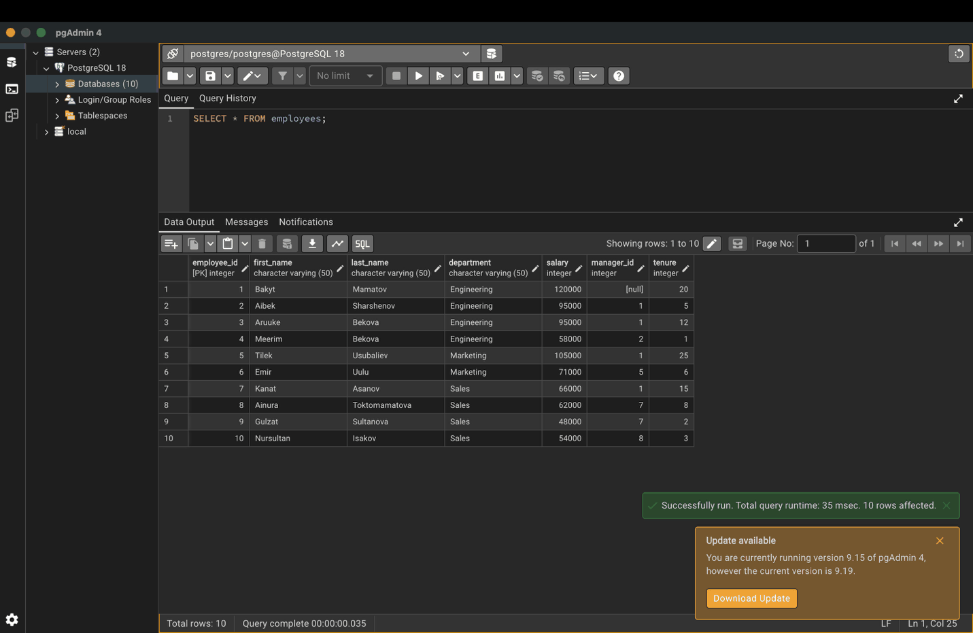

Part 2. Subqueries

Step 4. Scalar subquery: salary above the company average
SELECT first_name, last_name, salary
FROM employees
WHERE salary > (
SELECT AVG(salary) -- returns a single value
FROM employees
);
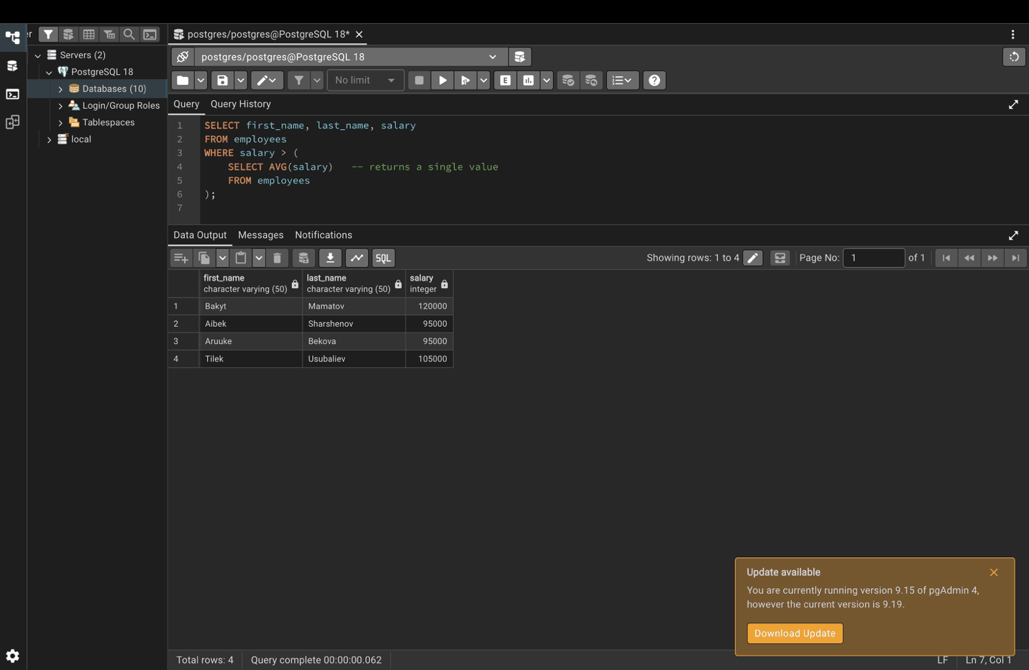

Step 5. Row subquery: same department and manager as Aruuke
SELECT first_name, last_name, department, manager_id
FROM employees
WHERE (department, manager_id) = (
SELECT department, manager_id -- returns one row with two columns
FROM employees
WHERE first_name = 'Aruuke'
);
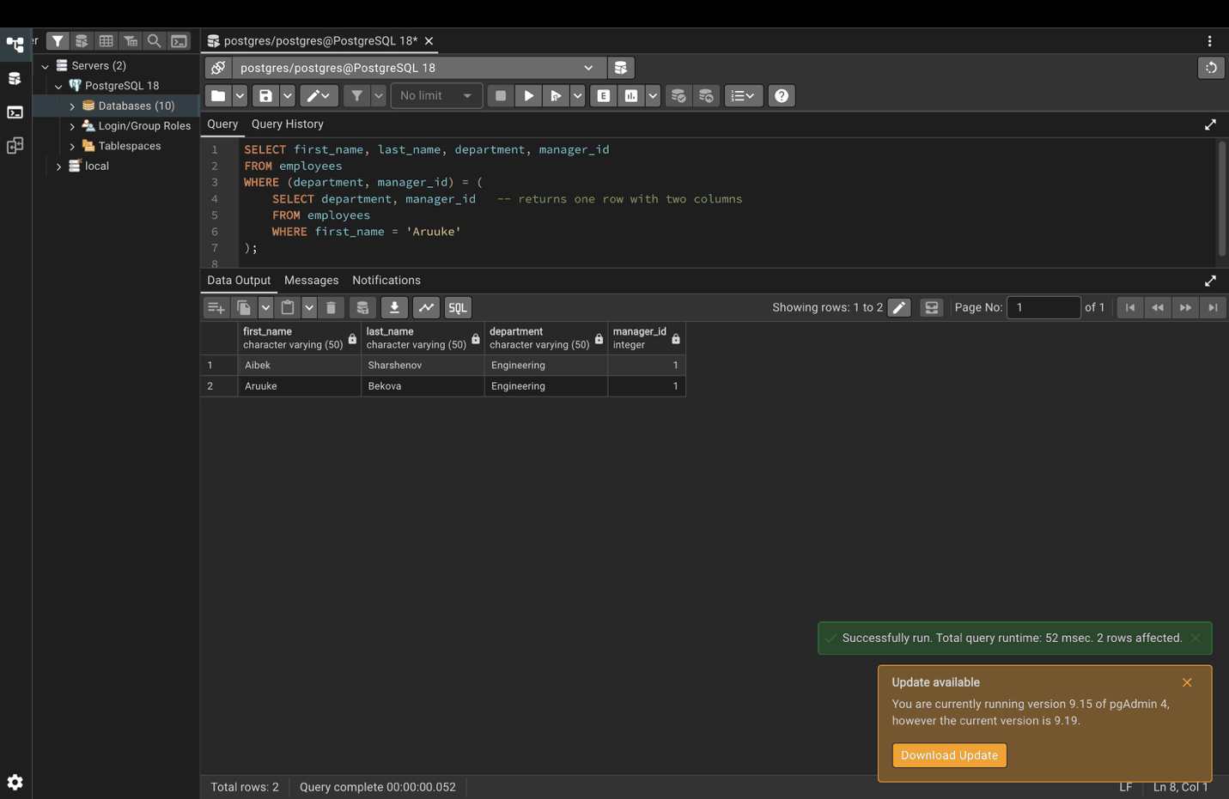

Step 6. Table subquery in FROM
SELECT department, avg_salary
FROM (
SELECT department, AVG(salary) AS avg_salary -- returns a full table
FROM employees
GROUP BY department
) AS dept_avg
WHERE avg_salary > 70000;
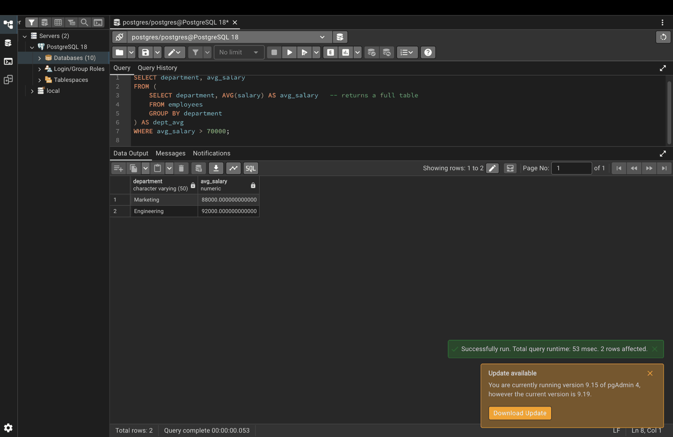

Part 3. Common Table Expressions (CTEs)

Step 7. Regions with total sales above 1000
WITH regional_sales AS (
SELECT region_id, SUM(amount) AS total_sales
FROM orders
GROUP BY region_id
)
SELECT region_id, total_sales
FROM regional_sales
WHERE total_sales > 1000;
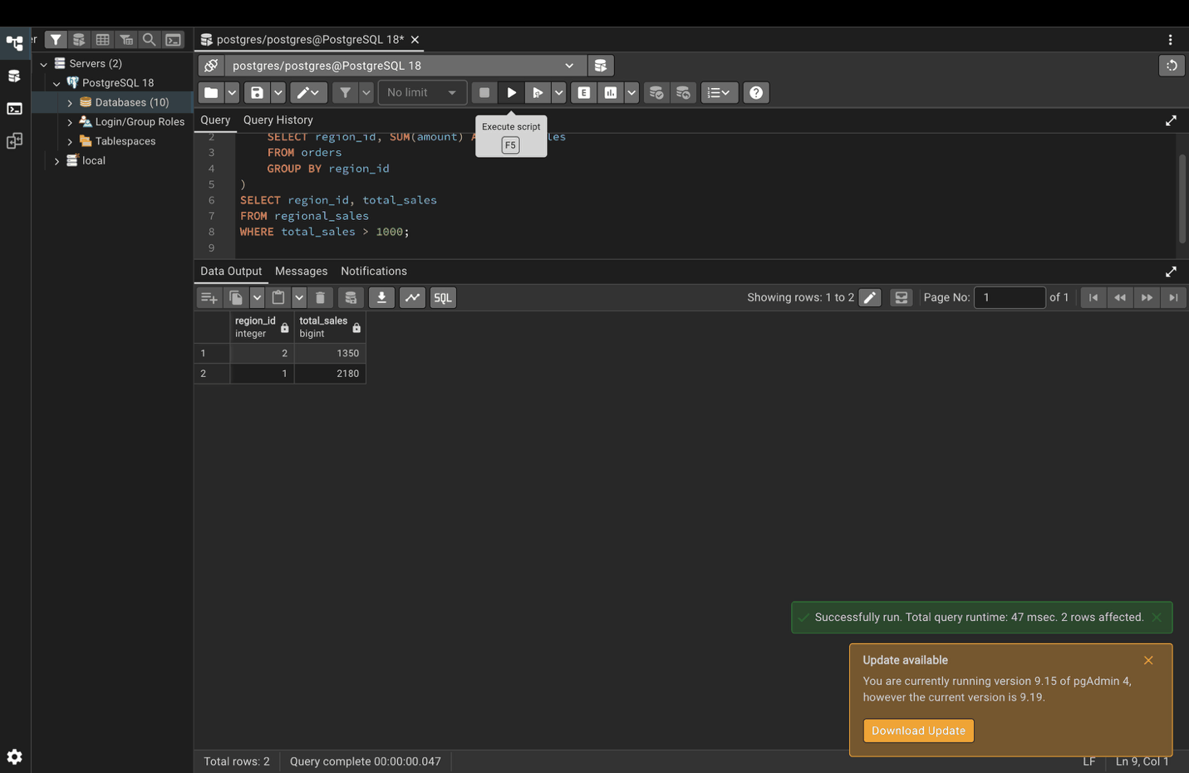

Part 4. Recursive queries

Step 8. Organization chart with WITH RECURSIVE
WITH RECURSIVE org_chart AS (
-- Anchor: the top-level manager
SELECT employee_id, first_name, last_name, manager_id
FROM employees
WHERE manager_id IS NULL
UNION ALL
-- Recursive: everyone who reports to people already in the chart
SELECT e.employee_id, e.first_name, e.last_name, e.manager_id
FROM employees e
INNER JOIN org_chart oc ON e.manager_id = oc.employee_id
)
SELECT * FROM org_chart;
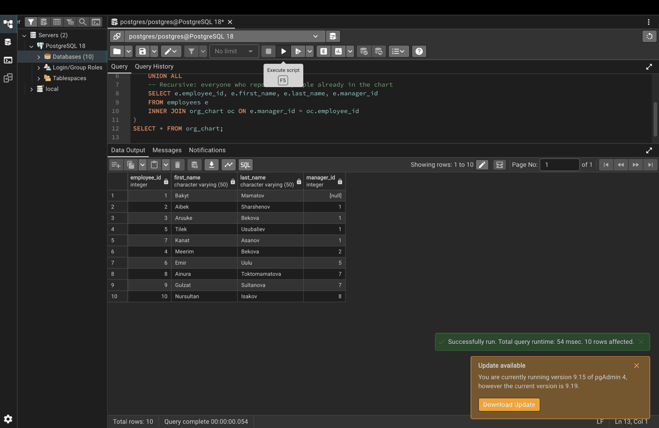

Part 5. Set operations

Step 9. UNION: unique products from both warehouses
SELECT product_name FROM warehouse_1
UNION
SELECT product_name FROM warehouse_2;
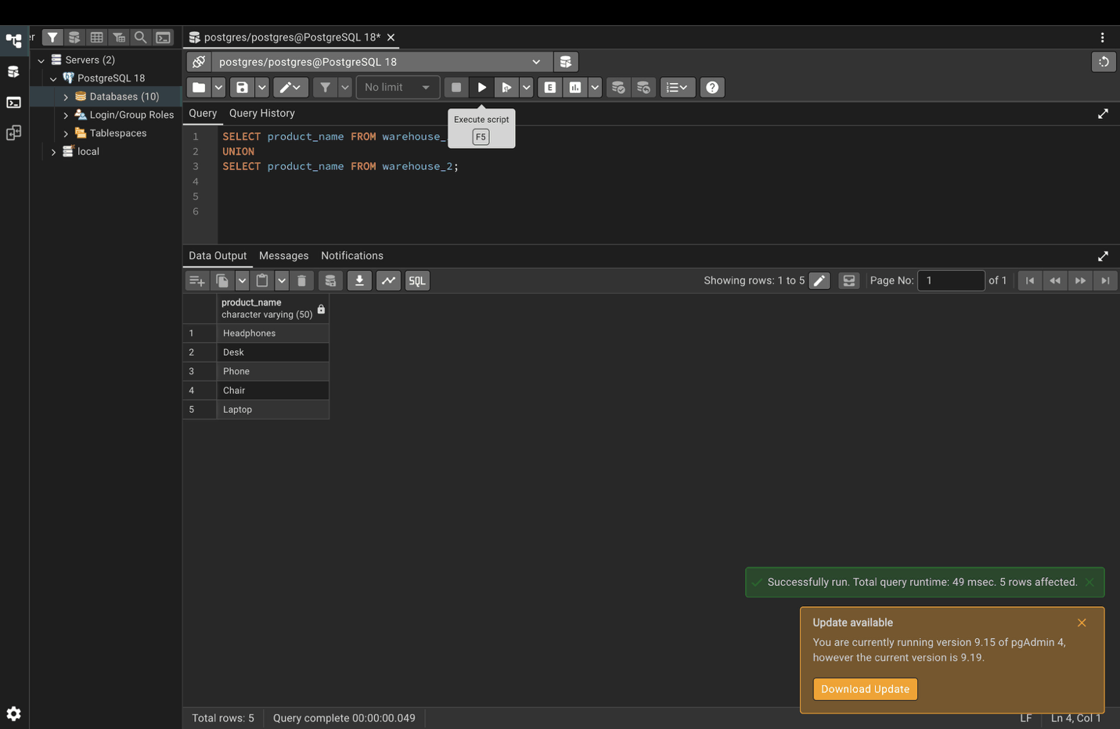

Step 10. UNION ALL: keeps duplicates
SELECT product_name FROM warehouse_1
UNION ALL
SELECT product_name FROM warehouse_2;
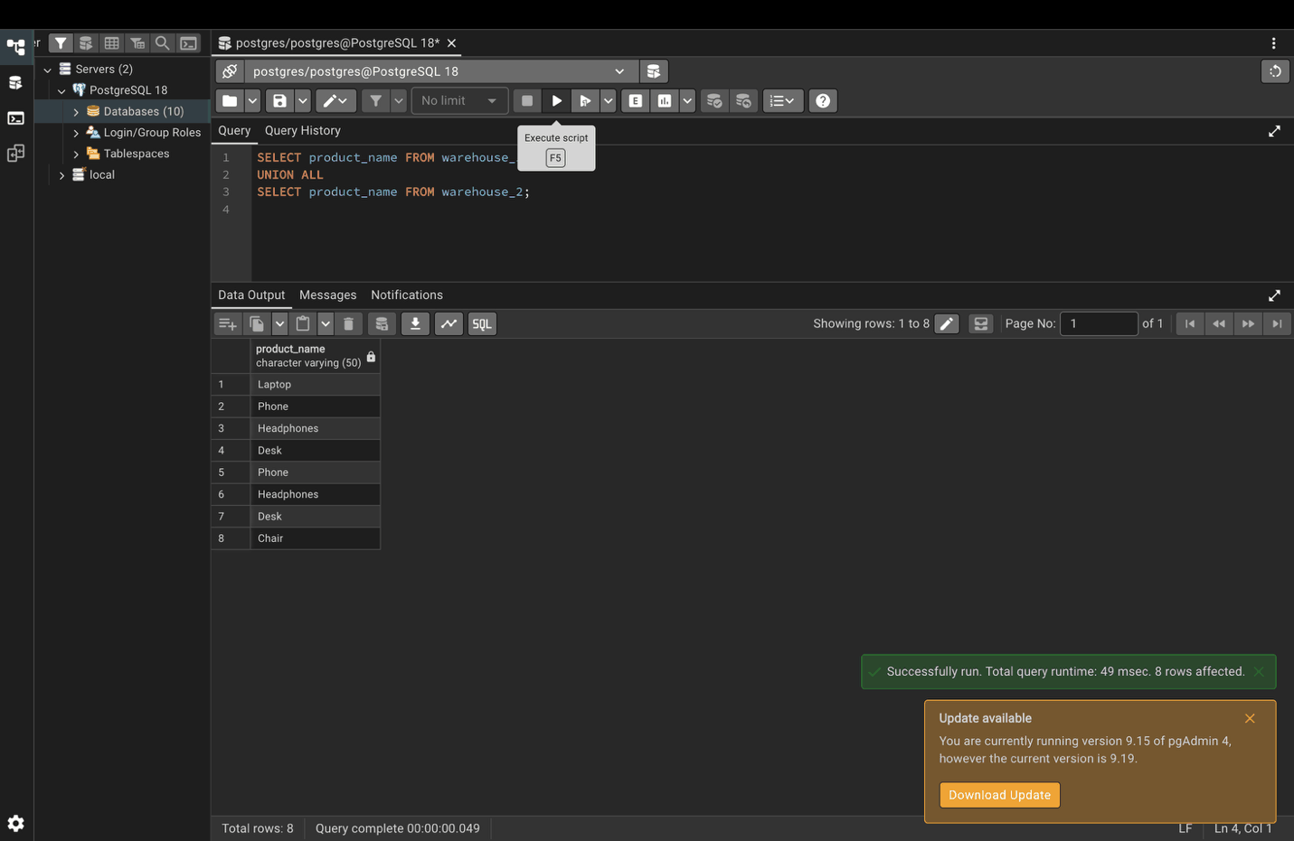

Step 11. INTERSECT: out of stock in both warehouses
SELECT product_id FROM warehouse_1 WHERE quantity = 0
INTERSECT
SELECT product_id FROM warehouse_2 WHERE quantity = 0;
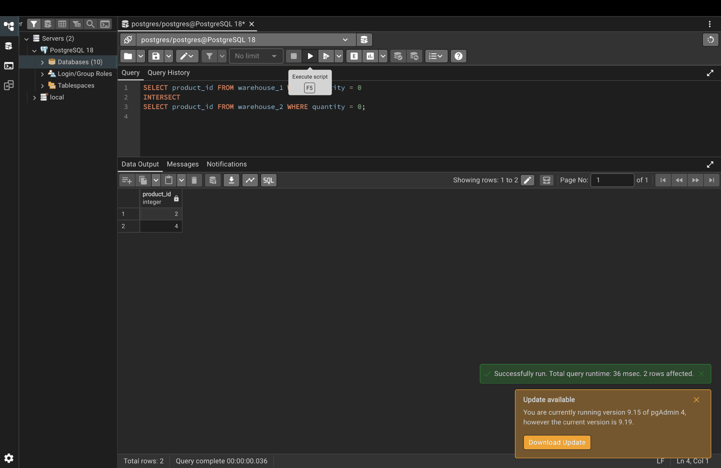

Step 12. EXCEPT: only in warehouse 1
SELECT product_name FROM warehouse_1
EXCEPT
SELECT product_name FROM warehouse_2;
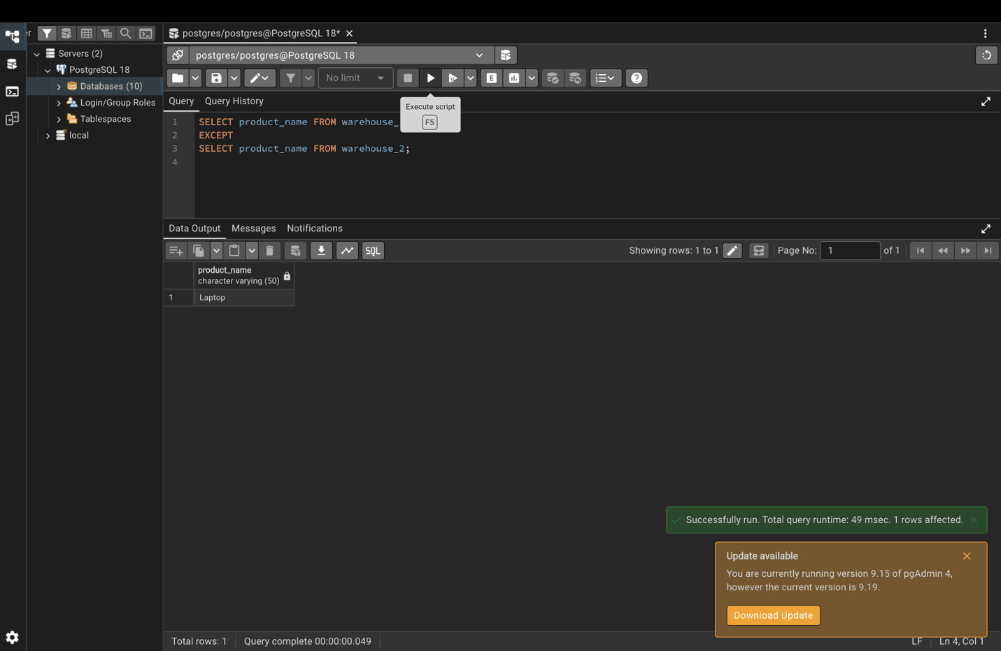

Part 6. Window functions and partitioning

Step 13. RANK within each department
SELECT
first_name,
last_name,
department,
salary,
RANK() OVER (PARTITION BY department ORDER BY salary DESC) AS dept_salary_rank
FROM employees;
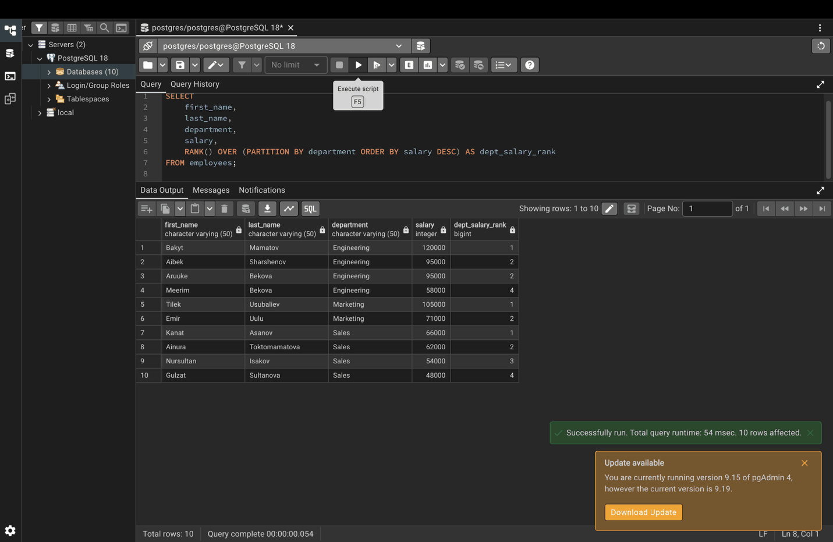

Step 14. ROW_NUMBER vs RANK vs DENSE_RANK
Aibek and Aruuke have the same salary: RANK skips the next number, DENSE_RANK does not.
SELECT
first_name,
salary,
ROW_NUMBER() OVER (ORDER BY salary DESC) AS row_num,
RANK() OVER (ORDER BY salary DESC) AS rank,
DENSE_RANK() OVER (ORDER BY salary DESC) AS dense_rank
FROM employees;
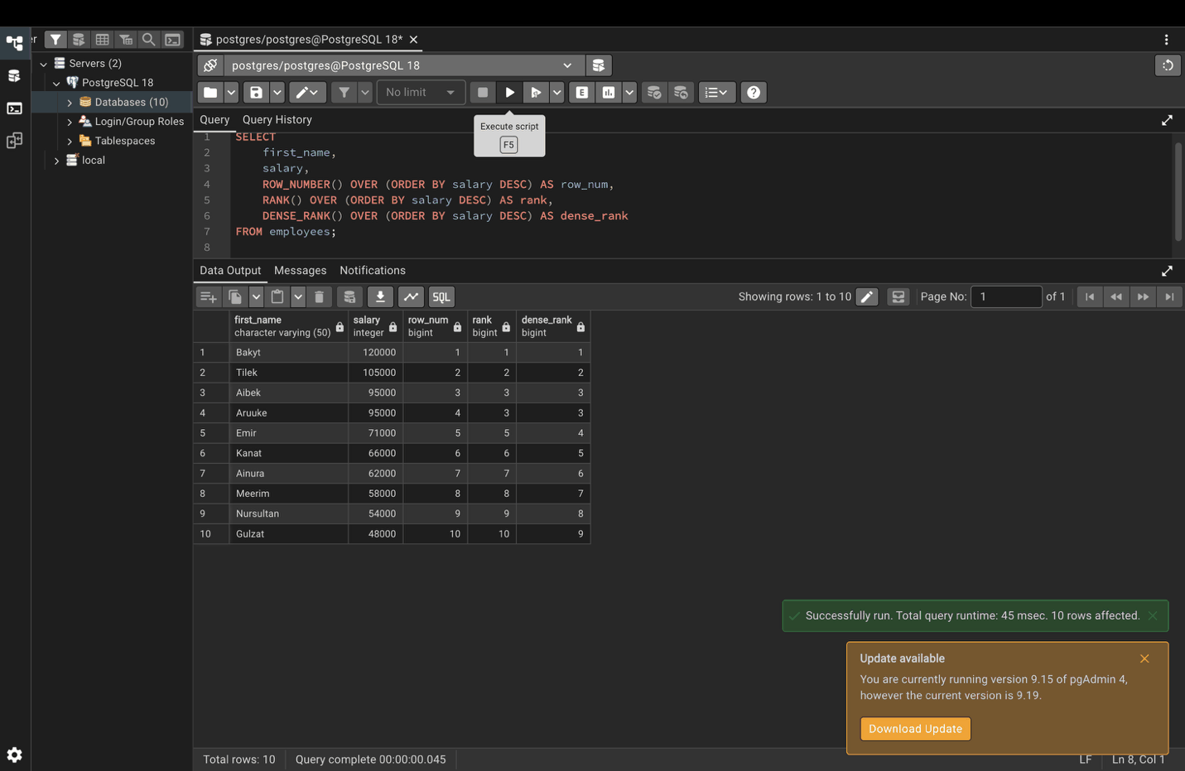

Step 15. LAG and LEAD
SELECT
product_name,
year,
sales_amount,
LAG(sales_amount) OVER (PARTITION BY product_name ORDER BY year) AS previous_year,
LEAD(sales_amount) OVER (PARTITION BY product_name ORDER BY year) AS next_year
FROM sales;
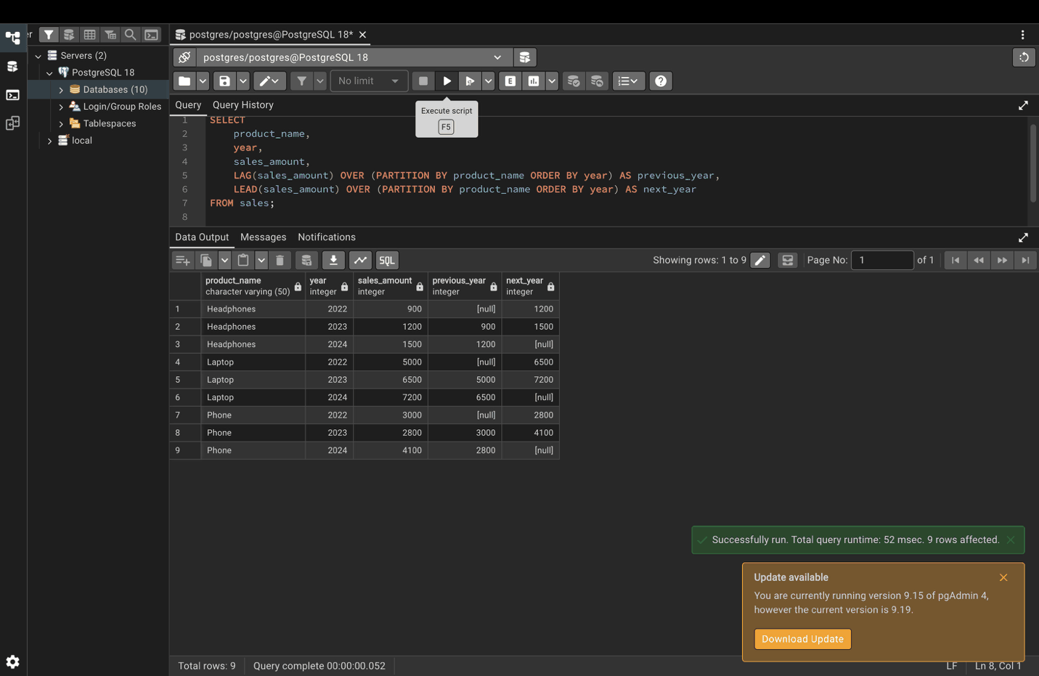

Part 7. Pivot and unpivot

Step 16. Pivot with conditional aggregation
SELECT
product_name,
SUM(CASE WHEN year = 2022 THEN sales_amount ELSE 0 END) AS year_2022,
SUM(CASE WHEN year = 2023 THEN sales_amount ELSE 0 END) AS year_2023,
SUM(CASE WHEN year = 2024 THEN sales_amount ELSE 0 END) AS year_2024
FROM sales
GROUP BY product_name;
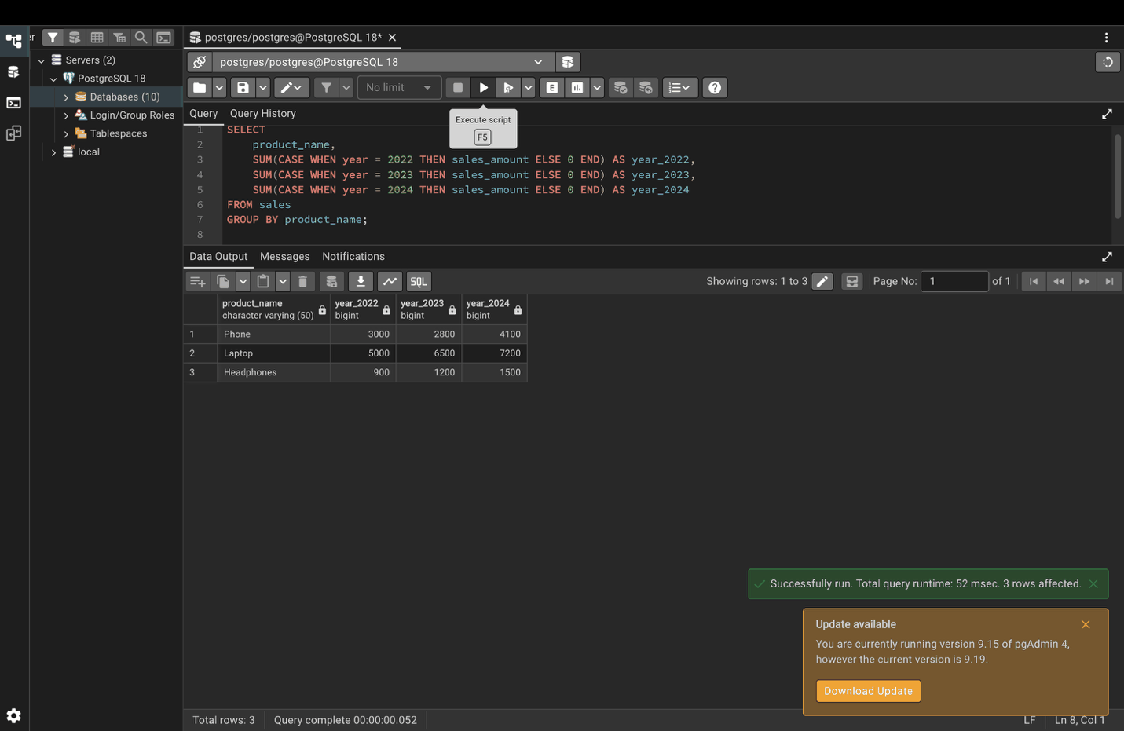

Step 17. Unpivot with UNION ALL
The pivoted result from Step 16 is turned back into rows.
WITH pivoted_sales AS (
SELECT
product_name,
SUM(CASE WHEN year = 2022 THEN sales_amount ELSE 0 END) AS year_2022,
SUM(CASE WHEN year = 2023 THEN sales_amount ELSE 0 END) AS year_2023,
SUM(CASE WHEN year = 2024 THEN sales_amount ELSE 0 END) AS year_2024
FROM sales
GROUP BY product_name
)
SELECT product_name, '2022' AS year, year_2022 AS sales_amount FROM pivoted_sales
UNION ALL
SELECT product_name, '2023' AS year, year_2023 AS sales_amount FROM pivoted_sales
UNION ALL
SELECT product_name, '2024' AS year, year_2024 AS sales_amount FROM pivoted_sales
ORDER BY product_name, year;
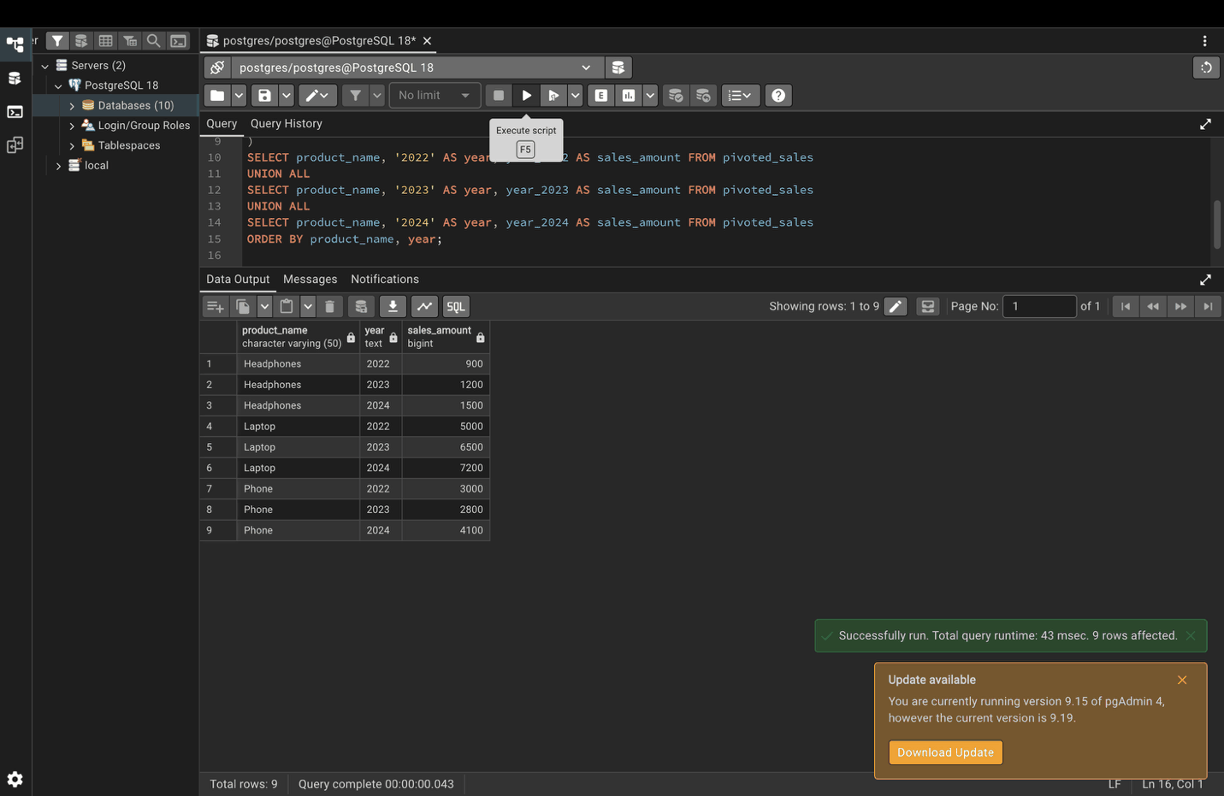

Part 8. Complex filtering and sorting

Step 18. FILTER clause
SELECT
employee_id,
first_name,
SUM(salary) OVER (PARTITION BY department) AS total_dept_salary,
AVG(salary) FILTER (WHERE tenure > 5) OVER () AS avg_salary_senior
FROM employees;
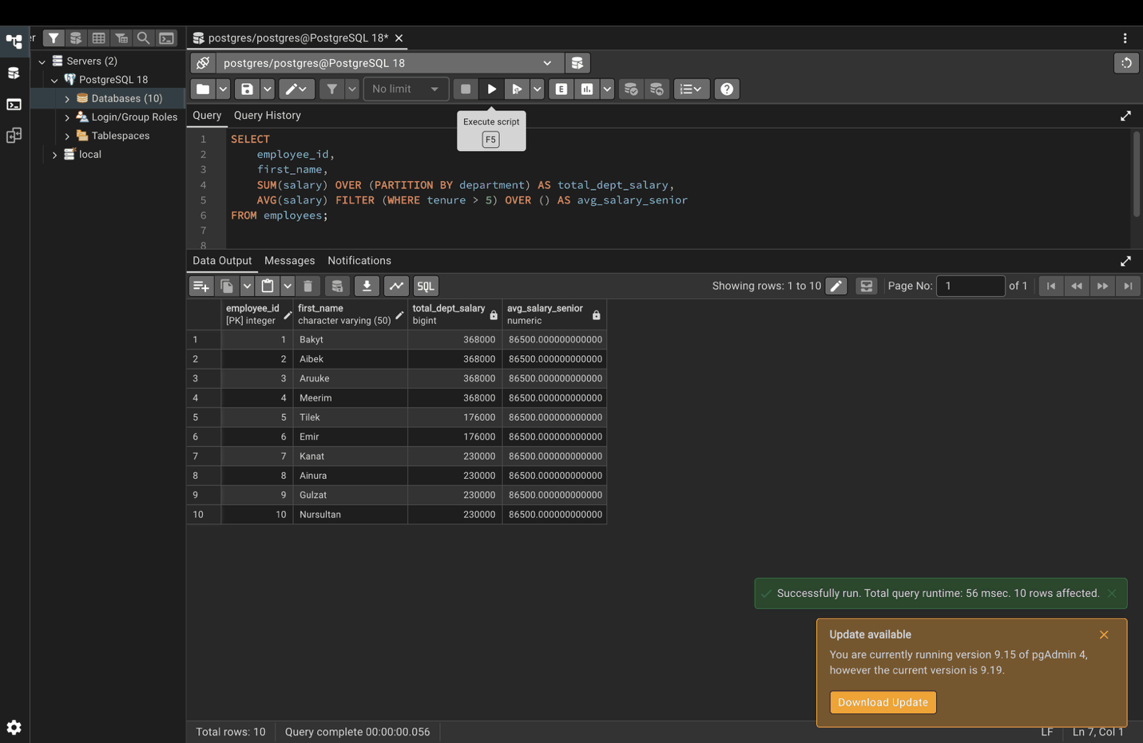

Step 19. Custom sorting with CASE
SELECT product_name, status
FROM orders
ORDER BY
CASE status
WHEN 'High Priority' THEN 1
WHEN 'Medium Priority' THEN 2
WHEN 'Low Priority' THEN 3
ELSE 4
END;
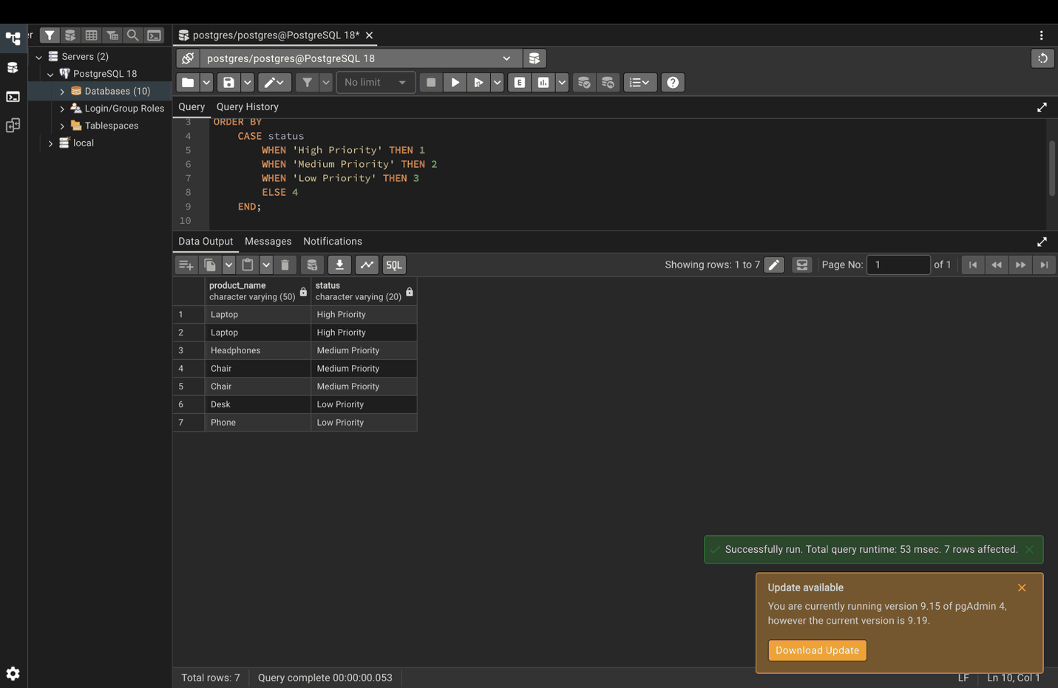

Part 9. Query optimization

Step 20. EXPLAIN: show the plan
EXPLAIN
SELECT first_name, salary
FROM employees
WHERE department = 'Sales';
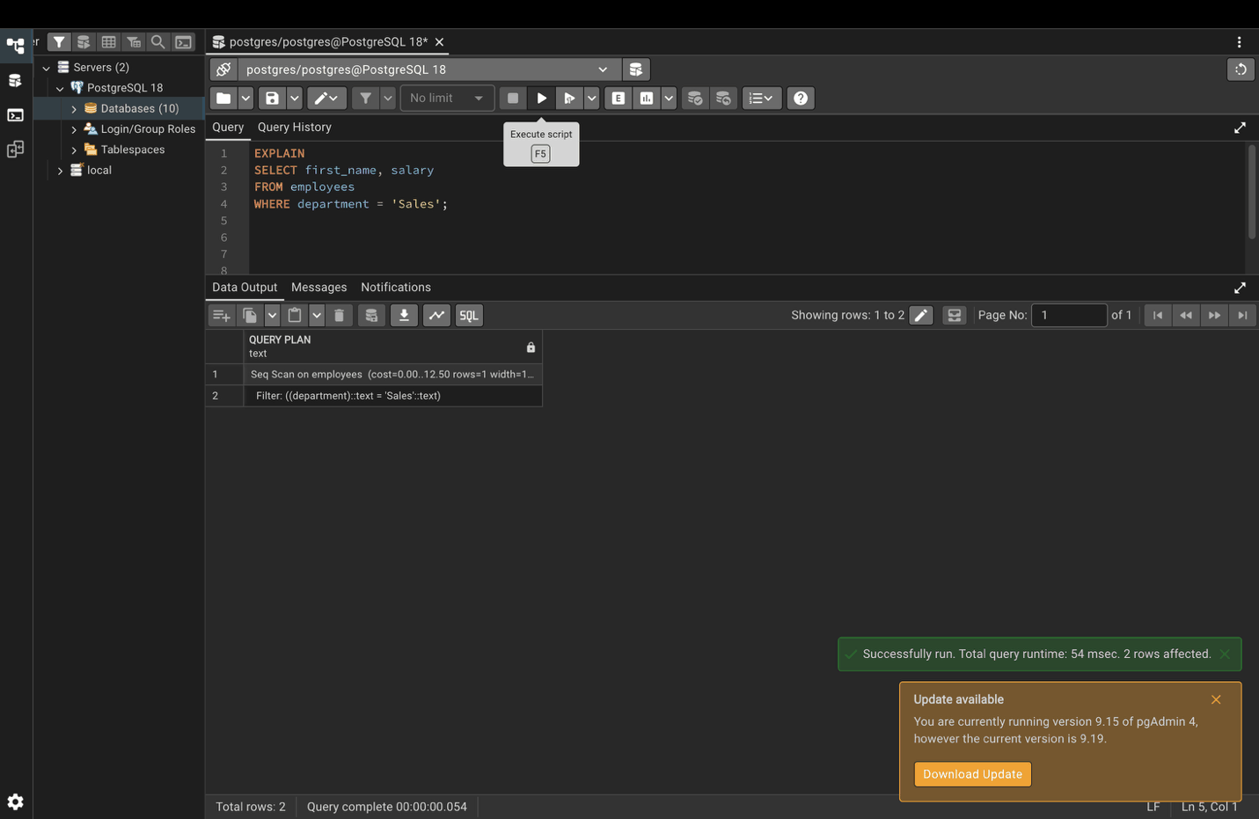

Step 21. EXPLAIN ANALYZE: run the query and show real timing
EXPLAIN ANALYZE
SELECT first_name, salary
FROM employees
WHERE department = 'Sales';
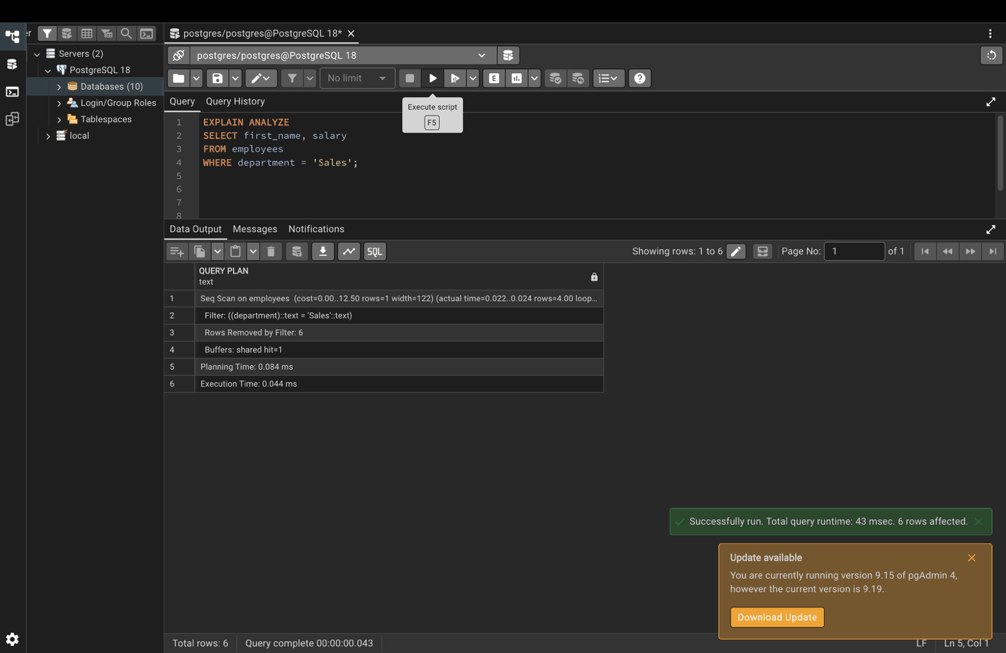

Step 22. LIMIT for testing
SELECT first_name, last_name, salary
FROM employees
ORDER BY salary DESC
LIMIT 3;


